Blob Storage: upload, lifecycle and recovery
  - Portal-first beginner hands-on lab
LBS | Attendee edition v2 | 26 October 2026

Before you start
Environment: use the instructor-approved sandbox, group, region, tiers and spending limit. Create only your own disposable resources. The walkthrough uses fictional data. No cloud resource is created by reading this document.
Materials: copy Labs\AppServiceSqlSample locally when the lab needs the .NET sample. Complete its setup from 02_Windows_And_Local_SQL_Setup.docx. Do not repeat resource creation if you already completed the same lab in the main guide.
Admin assistance: Contributor does not automatically grant IAM role assignment, SQL SELECT, Blob data access or Service Bus data access. Have the authorised administrator perform only the privileged step. Never bypass policy.
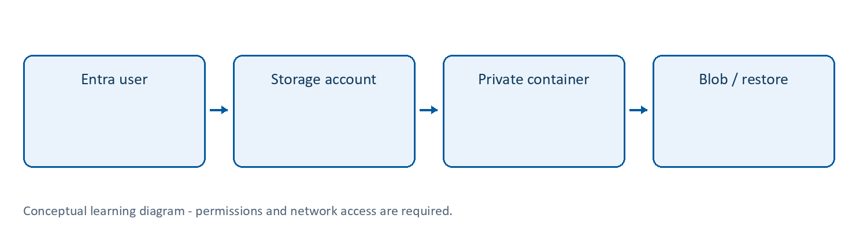
Learning flow

Storage account and Blob Storage | Documents and objects
What: a storage account is a management/security/billing boundary for supported storage services. Blob Storage stores objects in containers, identified by blob names. It is not a relational database.
Why/when: store documents, images, exports and large files separately from application processes. Use appropriate blob access tiers, redundancy and lifecycle policies for the data’s access/recovery requirements.
How: create the account, a private container and scoped data roles; upload/download through the portal or Azure.Storage.Blobs SDK using an authorised identity. Follow Lab 6.
Example: a fictional application supporting document is stored privately; a message carries its blob name, not the document bytes.
Tips and traps: account Contributor is not automatically Blob Data Contributor. A copied blob URL is not permission to download it. A SAS is a bearer credential: constrain scope and lifetime if approved; never paste it into shared notes. LRS redundancy is not protection against every disaster or accidental deletion. A lifecycle deletion rule can remove valuable files; test against an isolated prefix.
Reference: https://learn.microsoft.com/azure/storage/blobs/storage-blobs-introduction

Lab 6 | Blob Storage through the portal (extension)
Time: 25 minutes. Needs: Lab 1 and data-role assignment assistance. Cost: stored data and operations.
- Create stlbs<suffix> as a Storage account in the approved region. Choose Standard, general-purpose v2 and LRS for this disposable lab only, subject to policy. Keep secure transfer required, minimum TLS 1.2 or later, and anonymous blob access disabled.
- Under Data storage > Containers, create documents with private/no anonymous access.
- Have the role administrator grant your learner Storage Blob Data Contributor at the storage account or container scope. Management Contributor is not sufficient for Entra data access.
- In the container, switch the portal authentication method to Microsoft Entra user account where offered. Use the approved network route; do not open a firewall broadly to make upload work.
- Upload a small fictional text file, then download it and verify its contents.
- Inspect its Blob URL. Opening that URL in an unauthenticated browser should not grant public access. Do not turn on public access to fix an expected denial.
- Review Data management > Lifecycle management. Draft, but do not apply, a rule for disposable blobs in documents/ to delete after an approved period. Explain that a lifecycle rule can permanently remove data.
Checkpoint: authenticated upload/download succeeds and anonymous access is denied. Record the access method, not an account key or SAS token.

6A. Apply a safe lifecycle rule and inspect it
- In the private documents container, create/upload a fictional file under prefix exercise-only/. Confirm it is disposable.
- Open Lifecycle management > Add a rule, name it delete-disposable-lab-blobs, choose a filtered scope, and select block blobs.
- Add the prefix filter documents/exercise-only/ (container name included). Set deletion after 7 days since last modification, or the instructor-approved period.
- Review the filter and action with a partner before saving. Apply only on your private disposable account.
- Reopen the saved rule and verify it is enabled with the exact prefix. Lifecycle evaluation is asynchronous; do not expect immediate deletion or claim it was observed.
- Remove/disable the rule after verification if you intend to keep the files. Capture rule settings, not access credentials.

Lab 20 | Blob deletion protection and recovery
What/why: practise a recoverable mistake on fictional data. Availability redundancy is not the same as protection against accidental deletion.
Needs: private lab account; write permission for data-protection settings; Blob data permissions. Use a standard account without conflicting hierarchical namespace/immutability features; ask the instructor if options differ.
Cost: retained deleted blobs and versions can continue to consume billable storage.
- Open Storage account > Data management > Data protection. Record existing settings.
- With approval, enable Blob soft delete for an allowed short period such as 7 days on this disposable account. Save. Do not change unrelated protection/versioning options.
- Upload a new tiny fictional file named recovery-practice.txt to documents. Download once to verify its content.
- Delete only that blob using the portal and confirm its exact name. Never use a whole-container deletion for this exercise.
- In the container, enable Show deleted blobs (or the equivalent filter). Select the deleted blob and choose Undelete / Restore where offered.
- Download the recovered file and confirm its contents match.
- Inspect the configured recovery period and explain what happens after retention expires. Do not assume an indefinite recovery window.
- Remove the recovered practice file only when no longer needed. Do not purge retention-protected data to avoid charges or bypass controls.
Expected: the same disposable blob can be read after recovery.
Security: recovery permission is data access; never practise on a real customer file. Log note: portal success plus an actual download verifies recovery; an application home page does not.
Cleanup: retain approved protection while the account is used; final deletion follows Lab 13. Disabling protection can remove future recoverability; do not switch it off on shared storage.
Reference: https://learn.microsoft.com/azure/storage/blobs/soft-delete-blob-overview

Completion record and cleanup
Record | Your observation
Subscription/group/region and actual resource names
Expected result and actual result
Log/table/metric, time range and evidence
Identity, role/scope and network restrictions
Idle/usage/logging cost driver
Cleanup or retention owner/deadline
Only mark a lab passed after its functional checkpoint. A deployment success or empty error table alone is not proof. Mark blocked permissions honestly.
Clean up only your own disposable objects; removing a diagnostic setting does not erase retained logs, and stopping an app does not stop every cost. Follow Lab 13 in the main guide. Keep secrets/customer information out of evidence.
Verification scope: these instructions and Word file structure were reviewed. Automated Word pagination could not be completed; preview before printing. Azure execution, prices, policy, permissions, plan/runtime availability and portal labels require instructor rehearsal in the actual training subscription.

